

**Sixth Sunday a. Pentecost**

**July 21st, 2019**

**Season: Pentecost**



**100 E 3rd St Melvin IL 60952**

**Ph:217-388-4094 Cell:217-781-0933 MelvinLutheranChurch.org**

**St. Peter Free Lutheran Church**

***We Gather Together…***

Welcome and Announcements

Hymn [Stand]….…............“*God of Grace and God of Glory*”.………………….No.415

Confession & Forgiveness [Stand] ……….....…..…................................…… Page 56

Greeting & Kyrie [Stand] ……….……...............................................…… Page 57-59

Prayer [Stand] ……….………...........................................................…….…… Page 62

***We Hear God’s Word…***

Responsive Psalm …..........…..….....[Psalm 27:1–14]...........................Page 227

First Lesson …………………………………………................…………….Genesis 18:1–10a

Second Lesson ……………..………………..…….….....…………………Colossians 1:21–29

Alleluia [Stand] ………………………………………………..............………………………Page 62

Holy Gospel [Stand] ………………....................................................Luke 10: 38–42

Gospel Acclamation [Stand] ……………………................…...........................Page 63

Hymn [Stand]….….........“*If You But Trust in God to Guide You*”.…………….No.453

Passing of the Peace

Sermon ………………………………….[Source: CPR]……………………..*Sinful, Saintly Sisters*

Apostle’s Creed [Stand] …........................................................................Page 65

***We Offer Our Lives to Christ…***

Offering & Offertory …………..……….…………..........……………....……….…….Page 75

Prayer of the Church & Lord’s Prayer………………………………………………..Page 76

Benediction [Stand] ……………………………………………………..……………………..Page 76

Hymn [Stand] ……..…….“*He Leadeth Me: Oh, Blessed Thought!*”……………No.501

***Pastor:*** *“Go in Peace. Serve the Lord!”*  ***All:*** *“Thanks Be to God!”*

***Please remain seated if standing is uncomfortable for you.***

***Prayer is requested for…***

The confirmands, Sherry Hummel, Julie King, Nathan Harms, Shelby Nelsen, Jean Harms, and Bob & Bev Zebarth.

***Serving God’s Church… Pentecost 6 – July 21, 2019***

Greeter: **Today –** Hank H & Jonathan K **Jul 28th –** Hennessey Family

Reader: **Today –** Michelle B **Jul 28th –** Grace L

WMF: **Jul –** Nancy K & Michelle B **Aug –** Betty K & Lori H

***Next Week’s Lessons...***

**Jul 28th –** (Pentecost 7): Psalm 138; Gen. 18:(17–19) 20–33; Col. 2:6–15 (16–19); Luke 11:1–13

***Important Dates…***

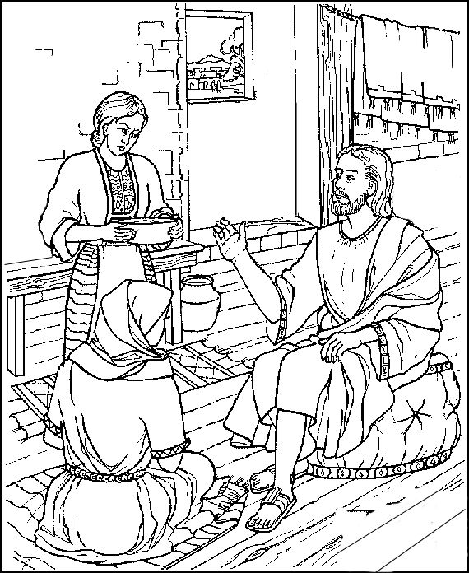Today (Jul 21)……………………………………….......................Women’s Group Meeting (after church)